Predictive Analysis
Task 2
Kiara Angelys Ganger
Western Governors University
D 209 | DATA Mining 1

Part I: Research Question

Purpose of the Data Mining Report:

Proposed Question:
Can we predict customer churn and identify key factors contributing to customer churn using Random Forests based on the available data?

Goal of the Data Analysis:
The goal of this analysis is to create a Random Forest model to predict whether a customer will churn or not. With the addition of identifying key factors causing those customers to churn.

Part II: Method Justification

Reason For Prediction Method:

How Radom Forest Analyzes the Selected Data Set:
Random Forest is a machine learning algorithm that is flexible and easy to use. It combines multiple decision trees to create a ‘forest’. The Random Forest method will be analyzing the dataset by following the following steps:
- Data Splitting:
I will be diving the dataset into training and testing sets. The training set is to build the model and the test is to evaluate the performance
- Bootstrap Sampling:
Or bagging will involve creating multiple subsets of the training data by sampling with replacement. Each subset will be used to train an individual decision tree.
- Decision tree Construction:
For each subset of the training data, a decision tree is constructed. When building each tree, the algorithm does not consider all the features at every split. Instead, it randomly selects a subset of features to choose the best split. This process of randomly selecting features at each split helps to ensure that the trees are diverse and not too like each other.
- Voting/Averaging:
Once all the trees are trained, each tree makes its prediction on the test data. For classification tasks, the final prediction is determined by majority voting among the trees. For regression tasks, the predictions of all trees are averaged to produce the result.
(Bobbitt, A Simple Introduction to Random Forests, 2020)
Some of the expected outcomes of this analysis include:
- Robustness:
I am hoping this model will be more robust and less sensitive to noise in the dataset
- Feature Importance:
Random Forest provides an estimate of the impact of each feature in the prediction. This can be extremely useful in helping us understand the key factors in customer churning.
(Meltzer, 2023)

Assumption of Random Forest
One assumption of the Random Forest is that it assumes that the bootstrap samples used to train each decision tree are representative of the overall population. This assumption makes sure that the trees are diverse, and the ensemble model can generalize well to unseen data. If the sampling process results in subsets that are not representative, the model's performance may be compromised, especially in cases of data imbalance (Breiman, 2001).

Packages, Libraries and Justifications:
Packages:
- readr:
Purpose – readr is used to read data from files on R, like CSV files
Justification – Ideally, I tend to like to use the base r package but for this task, readr reads files about 10x faster than the base r package. Jobs that run longer will have a progress bar which I won’t have with the base r package, and it doesn’t alter column names
- dplyr:
Purpose – dplyr have a set of functions that allow for data manipulation and data cleaning
Justification – This is useful for preparing the data for any kind of analysis. Due to its abilities to filter, select, and mutation datasets.
- dummy:
Purpose – One Hot encoding
Justification – Converts categorical variables into a numeric format. dummy also gives each category its own column.
- ggplot2:
Purpose – ggplot2 is a data visualization package.
Justification – With ggplot2 I will be able to create visualize analysis to view patterns, trends and the distribution of the data
- caret:
Purpose – caret has the functions needed for complex regression and classification problems
Justification – With caret I can split the data into train and test groups, model training and create a evaluation model. This makes the model much easier and more standardized.
- randomForest:
Purpose – Contains tools for implement Random Forest
Justification – RandomForest is specifically designed to build Random Forest models
- car:
Purpose – Companion to Applied Regression (CAR) tools
Justification –is used for regression analysis. Its great for finding collinearity and will allow me to run the vif() function
- pROC:
Purpose – ROC curve analysis
Justification – Has tools for visualizing, smoothing, and comparing ROC curves
(Liaw & Wiener, 2002)

Part III:Data Preparation

Performing Data Preparation

Data Preprocessing Goal:
My primary data preprocessing goal is to ensure that the dataset is clean and ready for modeling. This will involve dealing with any missing values, converting categorical variables into numeric format using label encoding or One-Hot encoding, and normalizing the numeric features if need be. By properly preprocessing the dataset I will help the Random Forest algorithm to efficiently analyze the data.

Initial Data Set Variables:
Variable | Type
Tenure | Numeric
Monthly Charge | Numeric
Bandwidth GB Year | Numeric
Outage Sec Per week | Numeric
Email | Numeric
Contacts | Numeric
Yearly Equipment Failure | Numeric
Population | Numeric
Age | Numeric
Income | Numeric
Children | Numeric
Item 1 | Numeric
Item 2 | Numeric
Item 3 | Numeric
Item 4 | Numeric
Item 5 | Numeric
Item 6 | Numeric
Item 7 | Numeric
Item 8 | Numeric
Gender | Categorical
Marital | Categorical
Phone | Categorical
Multiple | Categorical
Internet Service | Categorical
Online Security | Categorical
Online Backup | Categorical
Device Protection | Categorical
Tech Support | Categorical
Streaming TV | Categorical
Streaming Movies | Categorical
Contract | Categorical
Paperless Billing | Categorical
Churn (Target Variable) | Categorical

Data Preparation Steps
For this step I used a lot of my code from Task 1 of the course with a few small edits for the Random Forest classifier (Ganger, 2024).
- Step 1:
- Install and or load the packages and libraries
1. # Install Packages
2. install.packages("readr")
3. install.packages("dplyr")
4. install.packages("dummy")
5. install.packages("ggplot2")
6. install.packages("caret")
7. install.packages("randomForest")
8. install.packages("car")
9. install.packages("pROC")
10. # Load necessary libraries
11. library(readr) # For reading data
12. library(dplyr) # For data manipulation
13. library(dummy) # For one-hot encoding
14. library(ggplot2) # For data visualization
15. library(caret) # For model training and evaluation
16. library(randomForest) # For Random Forest Classifier
17. library(car) # For VIF calculation
18. library(pROC) # For ROC curve analysis
- Step 2:
- Load and inspect the data – Here I loaded the dataset using readr, and reviewed the structure
1. # Load the dataset
2. churn <- read_csv('C:/Users/kiara/OneDrive/WGU MSDA/D209/churn_clean.csv')
3. View(churn)
4. # Inspect the data
5. head(data)
6. str(data)
- Step 3:
- Check for and remove any null values, missing data, duplicates, and outliers
1. # Inspect the data for missing, duplicated or outliers
2. sum(is.na(churn))
3. sum(duplicated(churn))
4. # Function to identify and remove outliers using IQR method
5. remove_outliers <- function(df, var) {
6. Q1 <- quantile(df[[var]], 0.25, na.rm = TRUE)
7. Q3 <- quantile(df[[var]], 0.75, na.rm = TRUE)
8. IQR <- Q3 - Q1
9. lower_bound <- Q1 - 1.5 * IQR
10. upper_bound <- Q3 + 1.5 * IQR
11. df <- df[df[[var]] >= lower_bound & df[[var]] <= upper_bound, ]
12. return(df)
13. }
14.
15. # Apply the function to numeric variables
16. numeric_vars <- c('Children', 'Income', 'Outage_sec_perweek', 'Yearly_equip_failure', 'Tenure', 'MonthlyCharge', 'Bandwidth_GB_Year')
17.
18. for (var in numeric_vars) {
19. churn <- remove_outliers(churn, var)
20. }
- Step 4:
- Preform Label Encoding on Yes/No Variables and One Hot on Variables with 3 or more options
1. # Apply label encoding to other categorical variables
2. churn <- churn %>%
3. mutate(
4. Churn = ifelse(Churn == "Yes", 1, 0),
5. Phone = ifelse(Phone == "Yes", 1, 0),
6. Multiple = ifelse(Multiple == "Yes", 1, 0),
7. OnlineSecurity = ifelse(OnlineSecurity == "Yes", 1, 0),
8. OnlineBackup = ifelse(OnlineBackup == "Yes", 1, 0),
9. DeviceProtection = ifelse(DeviceProtection == "Yes", 1, 0),
10. TechSupport = ifelse(TechSupport == "Yes", 1, 0),
11. StreamingTV = ifelse(StreamingTV == "Yes", 1, 0),
12. StreamingMovies = ifelse(StreamingMovies == "Yes", 1, 0),
13. PaperlessBilling = ifelse(PaperlessBilling == "Yes", 1, 0)
14. )
15. # One Hot Encode
16. internet_dummies <- model.matrix( ~ InternetService - 1, data = churn)
17. churn <- cbind(churn, internet_dummies)
18. churn <- churn %>% select(-InternetService)
19.
20. gender_dummies <- model.matrix( ~ Gender - 1, data = churn)
21. churn <- cbind(churn, gender_dummies)
22. churn <- churn %>% select(-Gender)
23.
24. marital_dummies <- model.matrix( ~ Marital - 1, data = churn)
25. churn <- cbind(churn, marital_dummies)
26. churn <- churn %>% select(-Marital)
27.
28. contract_dummies <- model.matrix( ~ Contract - 1, data = churn)
29. churn <- cbind(churn, contract_dummies)
30. churn <- churn %>% select(-Contract)
- Step 5:
- Rename the dummy columns
1. # Rename the column for better coding
2. churn <- churn %>%
3. rename(
4. InternetService_None = `InternetServiceNone`,
5. InternetService_Fiber_Optic = `InternetServiceFiber Optic`,
6. InternetService_DSL = `InternetServiceDSL`,
7. Contract_Monthly = 'ContractMonth-to-month',
8. Contract_One_Year = 'ContractOne year',
9. Contract_Two_Year = 'ContractTwo Year',
10. Gender_Female = 'GenderFemale',
11. Gender_Male = 'GenderMale',
12. Gender_Nonbinary = 'GenderNonbinary',
13. Marital_Divorced = 'MaritalDivorced',
14. Marital_Married = 'MaritalMarried',
15. Marital_Never_Married = 'MaritalNever Married',
16. Marital_Separated = 'MaritalSeparated',
17. Marital_Widowed = 'MaritalWidowed',
18. Timely_Response = 'Item1',
19. Timely_Fixes = 'Item2',
20. Timely_Replacements = 'Item3',
21. Reliability = 'Item4',
22. Options = 'Item5',
23. Respectful_Response = 'Item6',
24. Courteous_Exchange = 'Item7',
25. Active_Listening = 'Item8'
26. )
- Step 6:
- Select variables for model dataset by creating a subset
1. # Subset of the Dataset with the variables for my initial model -1 dummy variable
2. variables_used <- c(
3. "Churn",
4. "Tenure",
5. "MonthlyCharge",
6. "Bandwidth_GB_Year",
7. "Outage_sec_perweek",
8. "Email",
9. "Contacts",
10. "Yearly_equip_failure",
11. "Population",
12. "Age",
13. "Income",
14. "Children",
15. "Timely_Response",
16. "Timely_Fixes",
17. "Timely_Replacements",
18. "Reliability",
19. "Options",
20. "Respectful_Response",
21. "Courteous_Exchange",
22. "Active_Listening",
23. "Gender_Female",
24. "Gender_Male",
25. "Marital_Divorced",
26. "Marital_Married",
27. "Marital_Never_Married",
28. "Marital_Separated",
29. "Phone",
30. "Multiple",
31. "InternetService_Fiber_Optic",
32. "InternetService_DSL",
33. "OnlineSecurity",
34. "OnlineBackup",
35. "DeviceProtection",
36. "TechSupport",
37. "StreamingTV",
38. "StreamingMovies",
39. "Contract_Monthly",
40. "Contract_One_Year",
41. "PaperlessBilling"
42. )
43. task_2 <- churn[variables_used]
44. View(task_2)
- Step 7:
- Although it may not have a significant impact on the model checking for correlation can help the overall diversity of the forest. Here I am checking for correlation:
1. # checking for correlation
2. ini_mod <- glm(
3. Churn ~ .,
4. family = "binomial",
5. data = task_2
6. )
7. vif(ini_mod)
8. 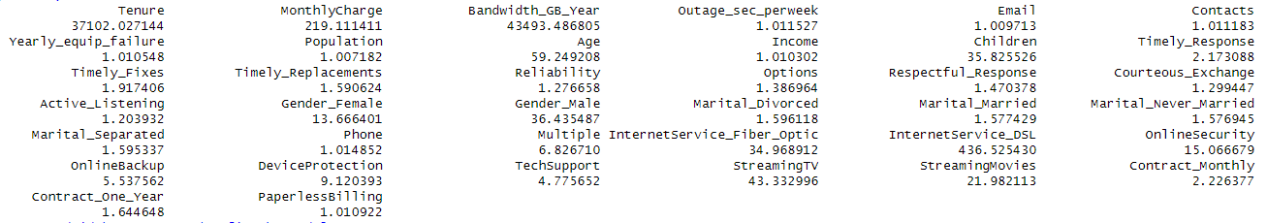
Since Bandwidth has an extremely high vif value I went ahead and removed it and reran the code
1. # Remove Bandwidth_GB_Year and refit the model
2. task_2 <- task_2 %>%
3. select(-Bandwidth_GB_Year)
4. # Refit the model
5. ini_mod <- glm(
6. Churn ~ .,
7. family = "binomial",
8. data = task_2
9. )
10. vif(ini_mod)
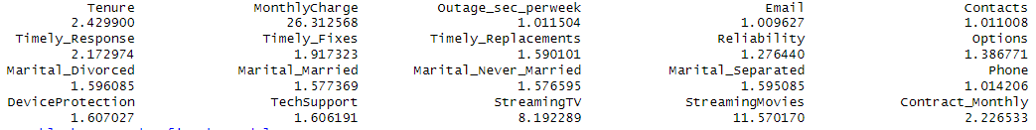
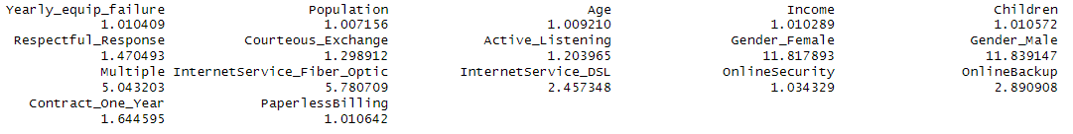
Now I can remove Monthly Charge.
1. # Remove MonthlyCharge and refit the model
2. task_2 <- task_2 %>%
3. select(-MonthlyCharge)
4. # Refit the model
5. ini_mod <- glm(
6. Churn ~ .,
7. family = "binomial",
8. data = task_2
9. )
10. vif(ini_mod)
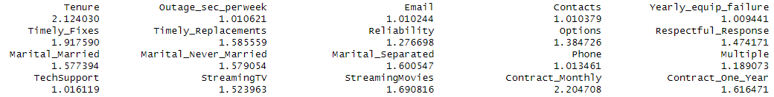
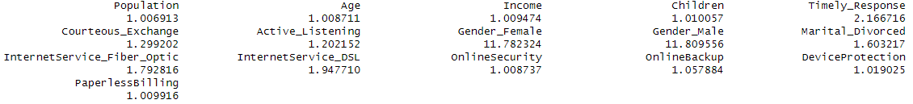
Here I am removing Gender Male.
1. # Remove Gender_Male and refit the model
2. task_2 <- task_2 %>%
3. select(-Gender_Male)
4. # Refit the model
5. ini_mod <- glm(
6. Churn ~ .,
7. family = "binomial",
8. data = task_2
9. )
10. vif(ini_mod)
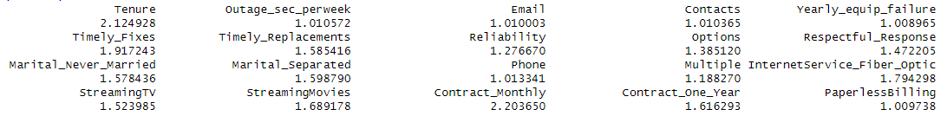
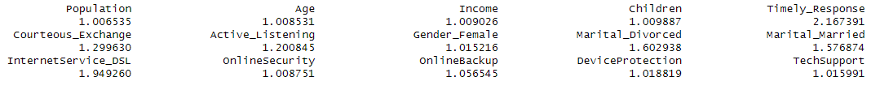
Now the model is ready to move on to the next step.
- Step 8:
- Drop unneeded columns and save the update
1. # drop unneeded variables
2. variables_kept <- c(
3. "Churn",
4. "Tenure",
5. "Outage_sec_perweek",
6. "Email",
7. "Contacts",
8. "Yearly_equip_failure",
9. "Population",
10. "Age",
11. "Income",
12. "Children",
13. "Timely_Response",
14. "Timely_Fixes",
15. "Timely_Replacements",
16. "Reliability",
17. "Options",
18. "Respectful_Response",
19. "Courteous_Exchange",
20. "Active_Listening",
21. "Gender_Female",
22. "Marital_Divorced",
23. "Marital_Married",
24. "Marital_Never_Married",
25. "Marital_Separated",
26. "Phone",
27. "Multiple",
28. "InternetService_Fiber_Optic",
29. "InternetService_DSL",
30. "OnlineSecurity",
31. "OnlineBackup",
32. "DeviceProtection",
33. "TechSupport",
34. "StreamingTV",
35. "StreamingMovies",
36. "Contract_Monthly",
37. "Contract_One_Year",
38. "PaperlessBilling"
39. )
40. task_2 <- task_2[variables_kept]
41. #write_csv(task_2, "C:/Users/kiara/OneDrive/WGU MSDA/D209/task_2.csv")
42. task_2 <- read_csv("C:/Users/kiara/OneDrive/WGU MSDA/D209/task_2.csv")
43. View(task_2)
44.

Clean data set:
- Please see file: task_2.csv

Part IV Analysis

Data Analysis and Report

Splitting the Data
In this step I split the data set into training and testing datasets. I used 80% of the data for training and 20% for testing.
Code for splitting the data:
1. # Split the data
2. set.seed(123) # For reproducibility
3. trainIndex <- createDataPartition(task_2$Churn, p = 0.8, list = FALSE)
4. trainData2 <- task_2[trainIndex, ]
5. testData2 <- task_2[-trainIndex, ]
6.
7. # Save the training and test datasets
8. write_csv(trainData2, "C:/Users/kiara/OneDrive/WGU MSDA/D209/traindata2.csv")
9. write_csv(testData2, "C:/Users/kiara/OneDrive/WGU MSDA/D209/testdata2.csv")
10.
- Please see files
- traindata2.csv
- testdata2.csv

Analysis Technique and Intermediate Calculations:
- Analysis Technique
For this analysis I used the Random Forest method. It creates multiple decision trees during training and then outputs the mean prediction of the individual tree for regression or the majority vote for classification. First, I spilt the data with the code provided in D1 then I created the Random Forest model on the training data by doing the following:
- I ran a quick code to confirm Churn was a factor
- Perform classification with random forest
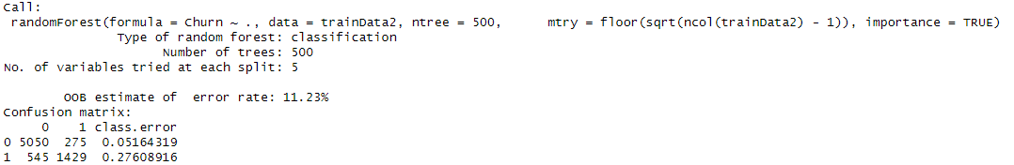
- Plotted model error rates
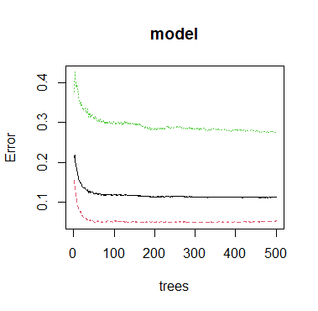
- Plotted Variable importance
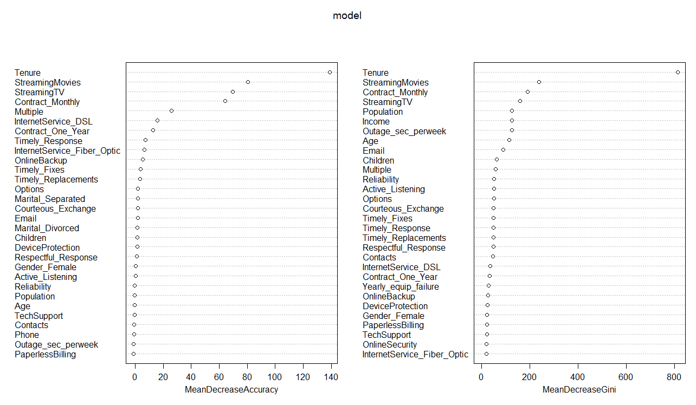
- Made sure predictions were factors with the same levels as the actual data
- Making Predictions and Evaluating the Model/Created the Confusion matrix
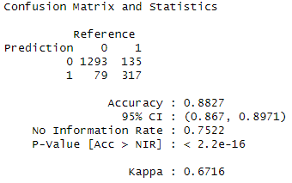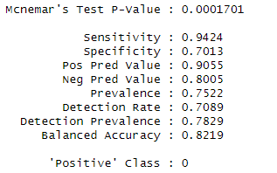
- Identify Optimal Values for Parameters Using Hyperparameter Tuning
- Instantiate the GridSearchCV() Object and Perform GridSearchCV:
R uses the caret package. Which is equivalent to GridSearchCV
- Print best parameters used
- Print best score for the top performing model
- Print MSE, RMSE, and R-Squared
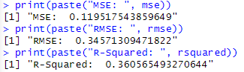
- Perform Predictions on the Test Data and Print Test Accuracy Score
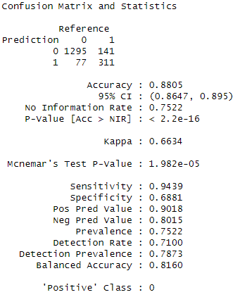

Code Used:
1. # Load training and test datasets
2. trainData2 <- read_csv("C:/Users/kiara/OneDrive/WGU MSDA/D209/traindata2.csv")
3. testData2 <- read_csv("C:/Users/kiara/OneDrive/WGU MSDA/D209/testdata2.csv")
4. View(testData2)
5. View(trainData2)
6.
7. # Convert the Churn variable to a factor for classification
8. trainData2$Churn <- as.factor(trainData2$Churn)
9. testData2$Churn <- as.factor(testData2$Churn)
10.
11. # Perform classification with random forest
12. model <- randomForest(
13. formula = Churn ~ .,
14. data = trainData2,
15. ntree = 500, # Number of trees
16. mtry = floor(sqrt(ncol(trainData2) - 1)), # Number of variables tried at each split
17. importance = TRUE
18. )
19.
20. # Print the model summary
21. print(model)
22.
23. # Plot model error rates
24. plot(model)
25.
26. # Variable importance plot
27. varImpPlot(model)
28.
29. # Predictions on test data
30. predictions <- predict(model, newdata = testData2)
31.
32.
33. # Ensure predictions are factors with the same levels as the actual data
34. predictions <- as.factor(predictions)
35. levels(predictions) <- levels(testData2$Churn)
36.
37. # Confusion matrix to evaluate the model
38. conf_matrix <- confusionMatrix(predictions, testData2$Churn)
39. print(conf_matrix)
40.
41. # Check the number of predictors
42. num_predictors <- ncol(trainData2) - 1 # subtracting the response variable
43.
44. # Ensure the mtry values are within the valid range
45. valid_mtry <- c(2, 4, 6, 8)
46. valid_mtry <- valid_mtry[valid_mtry <= num_predictors]
47.
48. # Perform hyperparameter tuning using caret with a valid mtry range
49. control <- trainControl(method = "cv", number = 3)
50. tunegrid <- expand.grid(.mtry = valid_mtry)
51. set.seed(42)
52. rf_model <- train(Churn ~ ., data = trainData2, method = "rf",
53. trControl = control, tuneGrid = tunegrid)
54.
55. # Best parameters from GridSearchCV
56. best_params <- rf_model$bestTune
57. print(paste("Best parameters: ", best_params))
58. best_score <- max(rf_model$results$Accuracy)
59. print(paste("Best Accuracy: ", best_score))
60.
61. # Mean Squared Error (MSE) - For regression
62. mse <- mean((as.numeric(predictions) - as.numeric(testData2$Churn))^2)
63. rmse <- sqrt(mse)
64. rsquared <- 1 - (sum((as.numeric(predictions) - as.numeric(testData2$Churn))^2) / sum((mean(as.numeric(trainData2$Churn)) - as.numeric(testData2$Churn))^2))
65. print(paste("MSE: ", mse))
66. print(paste("RMSE: ", rmse))
67. print(paste("R-Squared: ", rsquared))
68.
69. # Confusion matrix to evaluate the model
70. conf_matrix <- confusionMatrix(predictions, testData2$Churn)
71. print(conf_matrix)
72.
73. # Variable importance plot
74. varImpPlot(model)
(Bobbitt, How to Build Random Forests in R (Step-by-Step), 2020)

Part V: Data Summary and Implications

Summarize your analysis

Explanation of Model
For this analysis I used Random Forest classifier to predict customer churn. Below I proved an explanation of the performance metrics and classification metrics that will help with understanding the model’s preferences
Performance metrics
- Accuracy
The model on the test data had a score of 88.27%, meaning that 88.27% of the predictions made were correct.
- Mean Squared Error (MSE)
This score represents the average squared difference between the predicted probability of churn and the actual binary outcome. The model had a 0.1195 meaning it was closer to 0 than 1. Which means that the model is making accurate predictions
Classification metrics
- Sensitivity (Recall for class 0): 94.24%
- Specificity (Recall for class 1): 70.13%
- Positive Predictive Value (Precision for class 0): 90.55%
- Negative Predictive Value (Precision for class 1): 80.05%
- Balanced Accuracy: 82.19%

Discussion of my results and the Implications
- Results
Our Random Forest model was able to reach an accuracy of 88.27%, showing that it can reliably predict customer churn. The high sensitivity score of 94.24% means it is particularly good at identifying customers who won't churn, which is great for customer retention and satisfaction efforts.
On the other hand, the specificity score of 70.13% is lower. Meaning that the model struggles a bit with accurately identifying customers who will churn. This means that there might be room for improvement, such as fine-tuning the model or adding more relevant features.
- Implications
The implications of these results for the organization are serious. By being able to pinpoint customers at risk of churning, the company can take the necessary steps to keep them. For example, targeted marketing or personalized offers for those likely to churn can help with retention rates and overall customer satisfaction.

One Limitation
One limitation of the analysis is overfitting. Even thou the Random Forest model performs great on the test data, it may not perform the same to unseen data. For example, if the test set does not fully represent the diversity of real-world scenarios the model will encounter this can become an issue.

Recommended Course of Action
Based on the analysis and the model’s performance I can recommend the following:
- Better Data Collection
By collecting more up to date data and relevant on the customers interactions and behavior the company can add more features to the model. This can help improve the accuracy and predictive power.
- Customer Retention
To help retain customers I recommend they use the model to identify customers at high risk of churning. Creating discounts or rewards to intrigue them into staying or switching over to a better service that would better fit their family needs. They can do this by reviewing the survey response and other personal information such as if they have kids or are married. To create a more personalized offer for these customers (Ganger, 2024).

Part VI: Demonstration

Panopto Video
- Link:
ganger, kiara task 2 (panopto.com)

Code Source
Bobbitt, Z. (2020, November 24). How to Build Random Forests in R (Step-by-Step). Retrieved from Statology: https://www.statology.org/random-forest-in-r/
Elleh, F. (2023, August 15). Data Science Team. Retrieved from WGU SharePoint: https://westerngovernorsuniversity.sharepoint.com/sites/DataScienceTeam/Shared%20Documents/Forms/AllItems.aspx?isAscending=true&id=%2Fsites%2FDataScienceTeam%2FShared%20Documents%2FGraduate%20Team%2FD209%2FStudent%20Facing%20Resources&sortField=LinkFilena
Ganger, K. A. (2024). Task 1 D209.

References
Bobbitt, Z. (2020, November 24). A Simple Introduction to Random Forests. Retrieved from Statology: https://www.statology.org/random-forests/
Breiman, L. (2001, October). Random Forests. Machine Learning, 45, 5–32. doi:https://doi.org/10.1023/A:1010933404324
Liaw, A., & Wiener, M. (2002, May 23). Classification and Regression by randomForest. R News, 2(3), 18-22. Retrieved from cran.r-project: https://CRAN.R-project.org/doc/Rnews/
Meltzer, R. (2023, August 31). What Is Random Forest? Retrieved from CareerFoundry: https://careerfoundry.com/en/blog/data-analytics/what-is-random-forest/#how-does-the-random-forest-algorithm-work

